**CS 6301.004: Classroom Assignment – Clustering**

Teja Kiran Chunduri(txc163430)

**Clustering on Image**

**Original Image:**



**K values: 3, 5, 8, 10, 12, 15, 20, 30, 40, 50, 70**

**Elbow occurred at K=10, best K-value at K = 10.**

|  |  |
| --- | --- |
| **WCSS Plot** |  |
| **K = 3** |  |
| **K = 5** |  |
| **K = 10** |  |
| **K = 15** |  |
| **K = 20** |  |
| **K = 40** |  |
| **K = 50** |  |

**PCA on Image:**

The following are the reconstructed images using the projections of data of principal components.



 



The following is the compression ratio for each image compared to the original image:

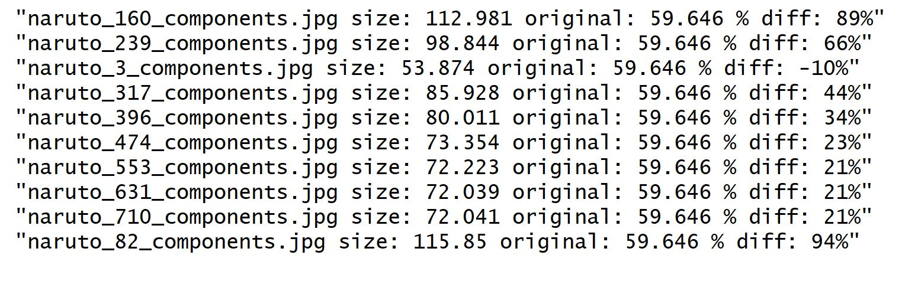

Run ClusterImage.R for KMeans clustering.

Run PCAImage.r for PCA. The compressed images will be stored in a folder “compression”, newly created in your working directory.